# Fair Value Gap: An Edge For Profitable Trading

So, right off the bat, what is a fair gap value(FGV)? An FVG, also referred to as an imbalance or liquidity void, is an area of imbalance in the market created by sudden price movement in one direction. But to understand this concept better, let's take a step back.

Consider this scenario. You see a strong upward movement characterized by long, bullish candles. What do you do? Like any other trader, you jump in and ride that [trend](https://capital.com/market-trend-definition). Rightly, the trend continues, but before long, it retraces, forcing you to exit the trade with a loss - dejected.

This is about to come to an end. In the dynamic trading environment, FVG gives you an invaluable edge. Read to the end to understand how FGV comes to your rescue. Let's start with how the gap forms.

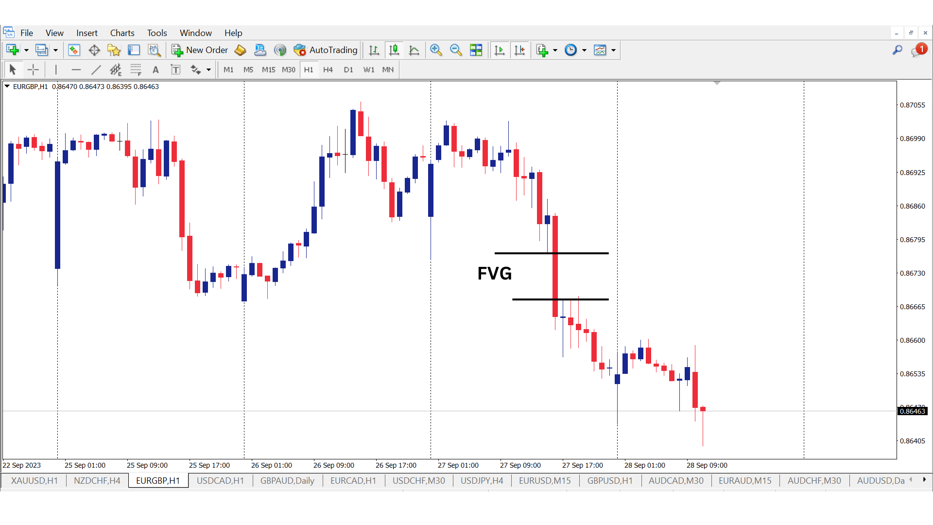

## What Causes a Gap

The concept of FVG is rooted in the understanding that the market tends to correct itself because price disparity isn't sustainable for long. When a big market player enters a market and opens a big position, the price moves irrationally before other participants join and balance the trade. This results in an imbalance. There are two types to identify the fair value gaps.

### Overvalue FVG

A massive bullish candle represents an overrated FVG. Ideally, the price is higher than its fair value. This means the price will fall to balance the inefficiency. The upward spike creates a trading opportunity in favor of buyers.

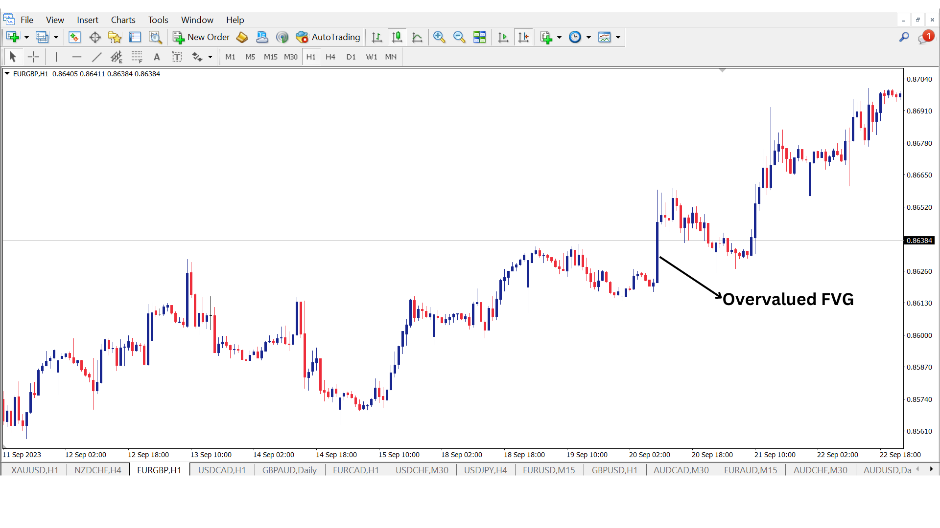

### Undervalued FVG

The undervalued FVG occurs when the price is lower than the fair value. Therefore, prices are poised to surge to balance the inefficiency. A massive bearish candle characterizes this gap. The bearish FVG experiences a rapid downward movement triggered by pessimism in the market or negative news interpreted as a potential selling opportunity where sellers expect further declines.

## How To Identify FVG

**FVG** is a three-candlestick pattern characterized by one big candle between two candles whose wicks don’t overlap the middle candle. A massive candlestick must appear and the candlesticks on either side should leave a gap between their wicks. In most cases, the candle forms during a lower time frame, but you can also identify it during higher time frames. Unlike other gaps where there is no trading activity, FVG actually represents trading activity. So, how do you identify a fair value gap, you ask? Here are vital signs to check.

* **Big Candle**

The idea is to find a sustained candle with a massive body-to-wick ratio, typically above 70%.

* **Neighboring candles**

Analyze the adjacent candles. Their wicks shouldn’t overlap. The gap between these candlestick’s wicks creates the FVG.

* **Define the FVG**

You must define and mark the FVG. In a bullish market, FVG is the area between the previous candle's high and the next candle's low. In bearish markets, the vice versa is true.

## How to Trade Fair Value Gap

There are various ways you can use the FVG. For instance, you can incorporate order blocks or supply and demand zones. During a buy, you want to buy from a [demand zone](https://learn.bybit.com/strategies/supply-and-demand-zones-strategies/) and exit when the price closes the gap. As a trader, you capitalize on this market correction to profit from the realignment. Alternatively, you can enter the market after the price has closed the gap and trade the initial trend.

Here are simple steps to guide you.

### Determine the Trend

The first step is to trade with the trend. This means if the market is forming higher highs and lower lows, you should check for bullish FVG. If need be, check the higher time frames.

### Identify the Supply and Demand Zones

After determining the dominant trend, the next step is identifying the demand and supply zones. These are areas in the market where massive significant price movements have happened in the past. Ideally, you should choose order blocks that align with the trend. In an uptrend, find demand zones where buying interest is likely to drive prices highs. Similarly, in supply zones, dominant selling pressure pushes prices lower.

### Use FVG to Enter the Market

The next step is to enter the market. Remember, the market is likely to correct and balance the gap. Once the gap is corrected, the market is likely to move in the direction of the initial trend. This approach works best when there is confluence. For instance, you capitalize on order block or [mitigation block](https://www.crysfoanalysis.com/how-to-use-mitigation-block-for-sniper-market-entries/)s to buy after the gap closes.

### Set Stop Loss and Take Profit

Lastly, set the take profit and stop loss. While the gap tends to get filled, it’s not always so. Ideally, you should place the stop loss below the demand zone in a bullish market and above the supply zone in a bearish market. Ideally, place the take profit in the next area of interest in the market's direction.

**Bounce at FVG Zone**

The other method is to wait for the price to close the gap. During the bullish market, the price will jump, creating an overrated fair value gap. Now, wait for the price to retrace to the FVG zone and close the gap. In most cases, the price bounces after filling the gap.

**Consequences Encroachment**

An encroachment means that the price might fill half of the FVG. Note that the price might not really fill in the gap. Consequent encroachment happens when the price fills 50% of the gap. This is referred to as the mean threshold of the FVG. You should target this mean threshold to catch the most winning trades.

## Essential Components of The Ideal FVG

When trading with FVG, there are vital components you must confirm.

1. **Timing**

In FVG, timing is everything. Ideally, you should look for gaps at kill zones. This period with high trading activity usually coincides with the London and New York open overlap.

1. **Liquidity**

The next important consideration is the liquidity. Essentially, liquidity manifests in the chart through stop-loss orders. Therefore, your deal here is to wait for the liquidity hunt. The market forms imbalances on five-minute charts following this hunt.

1. **Entry With Risk Management**

Now, it's time to go for the kill. Essentially, wait for the market to fill the FVG imbalance. Enter the market following proper risk management.

## What Does the FVG Tell You?

If you are observant, nature always tries to balance things out. Therefore, you should aim to catch that price correction in markets with an imbalance. This means an imbalance acts as a magnet that attracts the price. For example, if the price is overvalued, you should open a short position to take advantage of the price fall. In some cases, the FVG represents the break of [market structure](https://www.crysfoanalysis.com/winning-fundamental-analysis-hownews-events-shape-the-forex-market/)(BOS), hence a point of interest in the market.

## Example

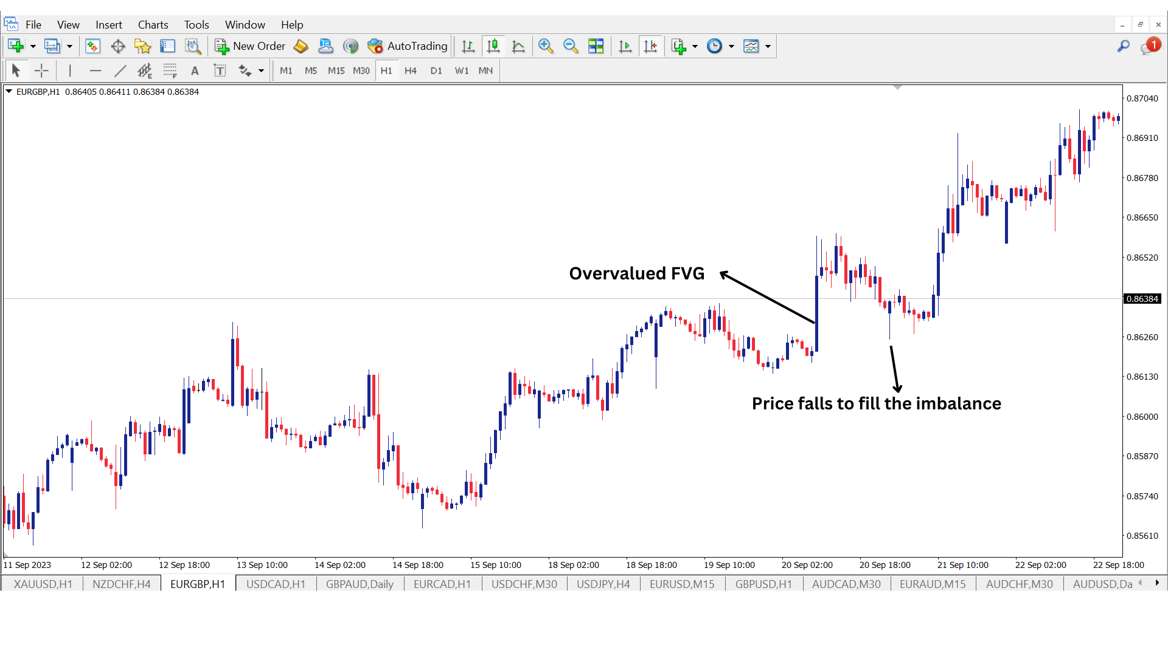

This picture gives you a clear illustration of a fair value gap that forms during a bullish market. Essentially, the EURGBP pair surge, creating an imbalance. The price then comes down to fill the imbalance.

## Conclusion

FVG is a trading pattern that results from rapid price movement. You can get insights into great potential trading opportunities by identifying these gaps. Leverage these gaps to enhance your trading decisions. Ultimately, you will see winning results!

**FAQ**

**Does FVG always get filled?**

While the FVG usually tends to get filled, FVGs represent the market imbalances that we expect to correct themselves, but it's not an absolute rule. However, sentiment, unexpected market movement, and other external factors can influence whether the FVG getS filled.